**Twitter Clone Using React and Spring Boot  
MySql and MUI**

DAY 1:

DAY 2:

1. Divided home page into 3 grid section 2 8 2.
2. Started building first section as a navigation section.
3. Need to import icons so imported it from MUI and pasted its code in NavigationMenu.jx, created array of menu.
4. Created Navigation.jsx and firstly set the logo of twitter, maped all navigation menu with its page and onclick function ,either it will direct the path or it will redirect to the profile(ternary operator) remember in jx `` is used it is not single inverted comma (location=below Esc button).
5. Created tweet button with blue color and variant= caontained to show text.
6. Now created username and pic section at the bottom,for name we used <span>.
7. Now there is button on right by clicking we r getting option of logout, for that we have to see code from mui menu copy js code only, copy button code and also define code at top remember to import impotant library for that (Menuitem,menu)

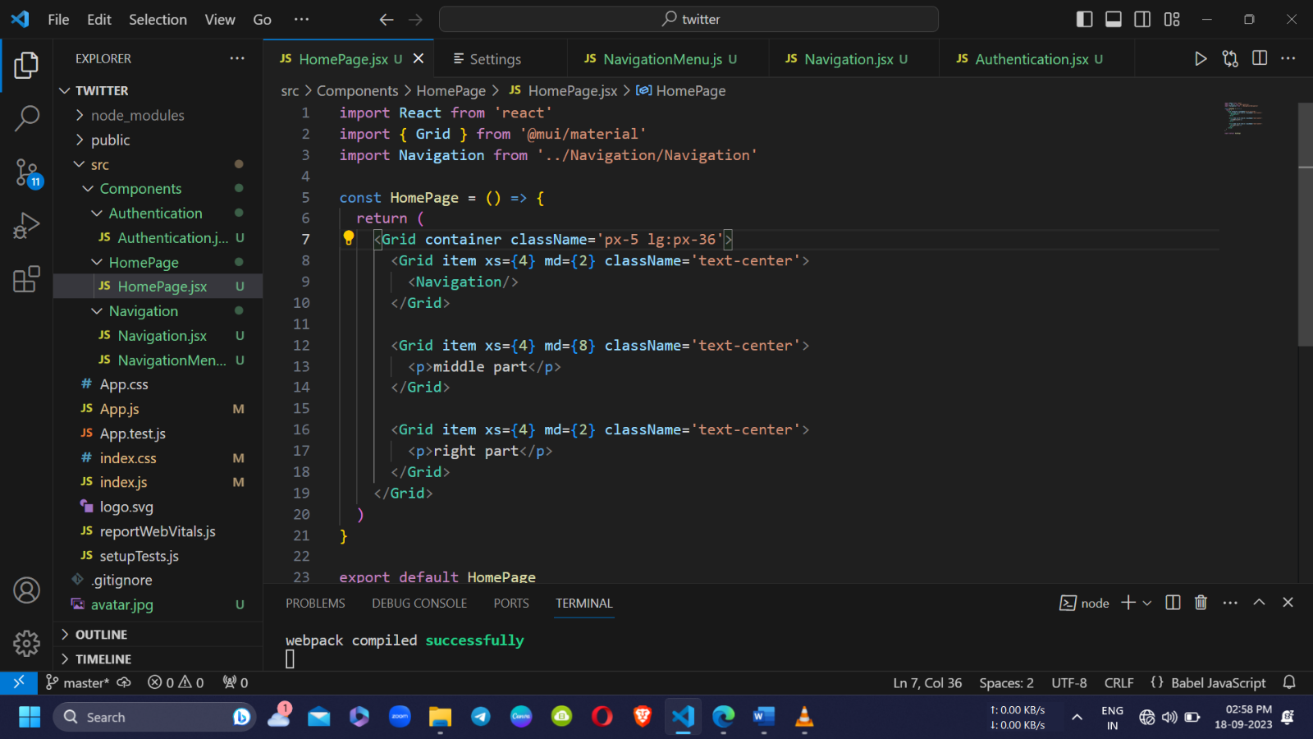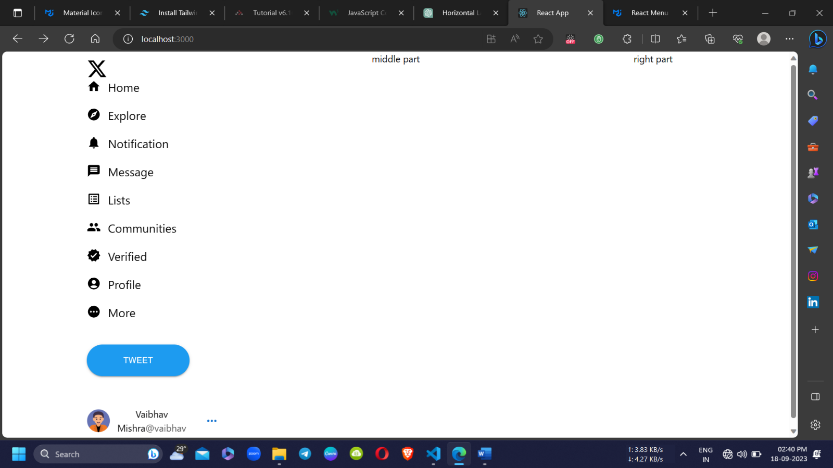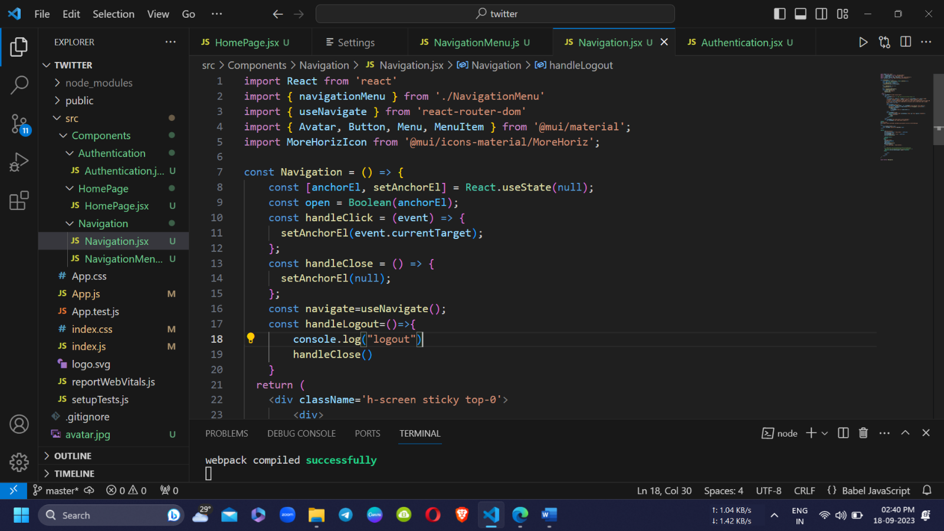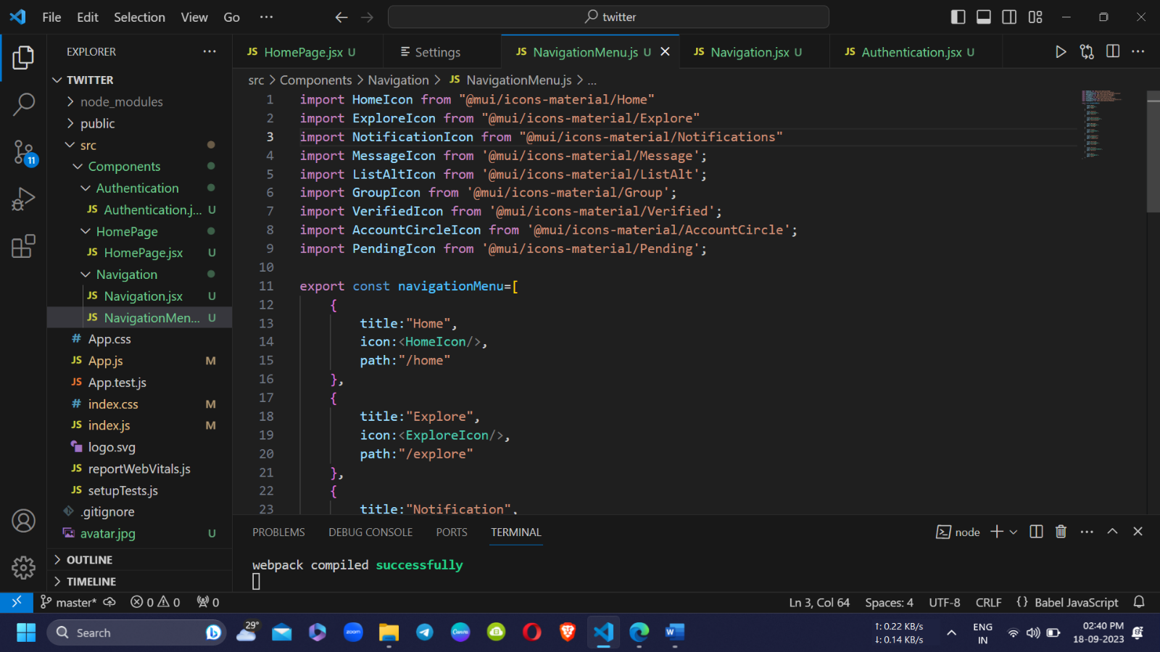

DAY 3: 19/09/23

1. Started building middle section, created folder of It and then jsx file of it.
2. Created avatar section and form section in the side of avatar
3. For middle section we need forms so install it on terminal (npm I formic and npm I yup).
4. Imported 3 icon image, location, emoji.
5. Linked image icon with event handler and written on click action
6. Created all states in image uploading event.
7. At last we had put the tweet button(same code as on navigation) ‘type=submit’
8. We have used onSubmit in the form by which it act as form submission in react.
9. <form onSubmit={formik.handleSubmit}> it is a function provided by Formik.

When the "Tweet" button is clicked, the form submission event is triggered, and the formik.handleSubmit function is called.

Inside formik.handleSubmit, you have defined a callback function named handleSubmit:

(it simply logs the form values to the console.)

10.baad me cloud pr bhejengey jab api link hoga tb.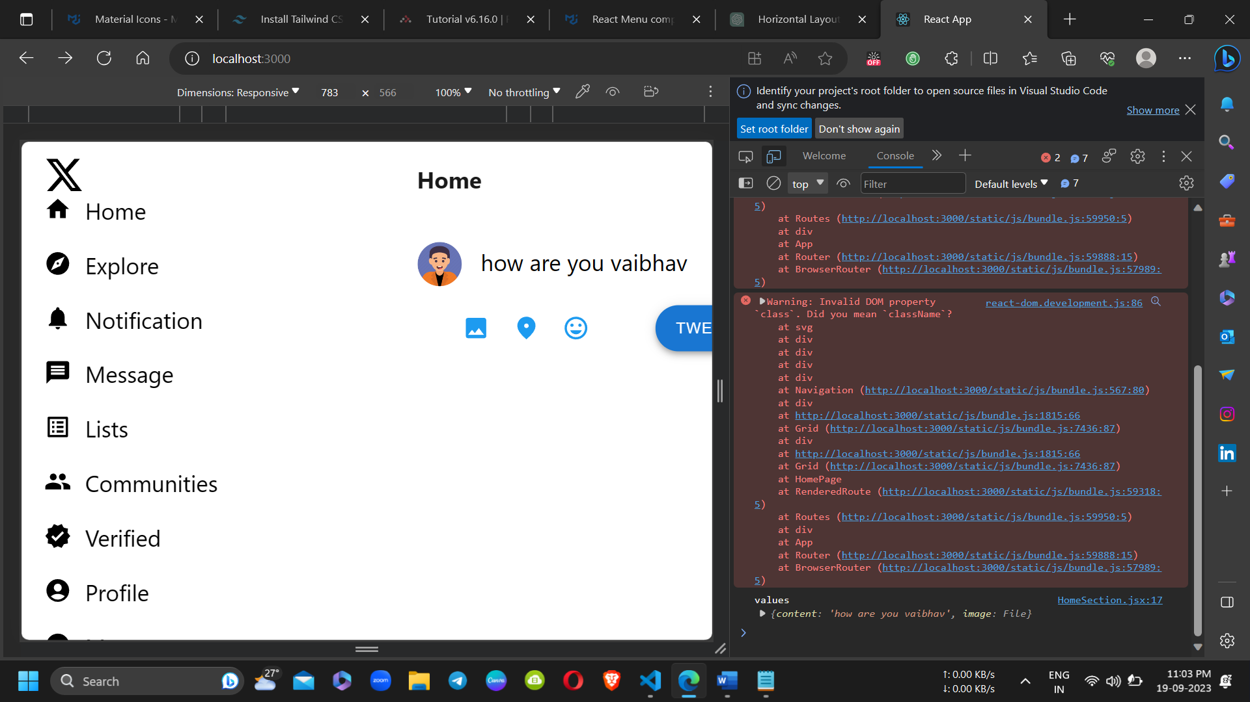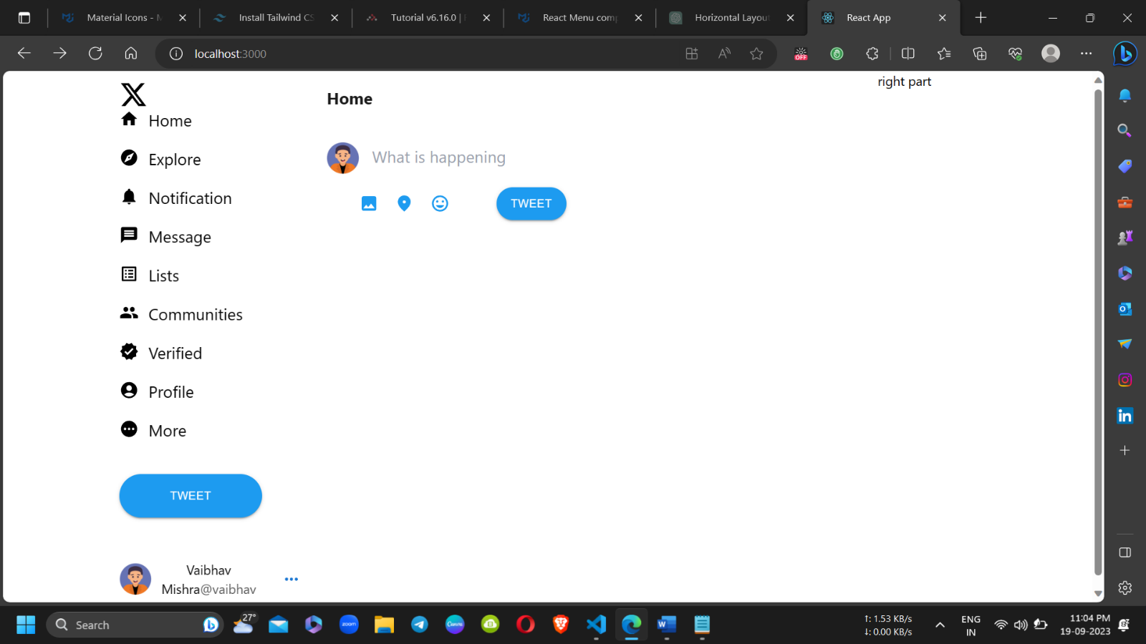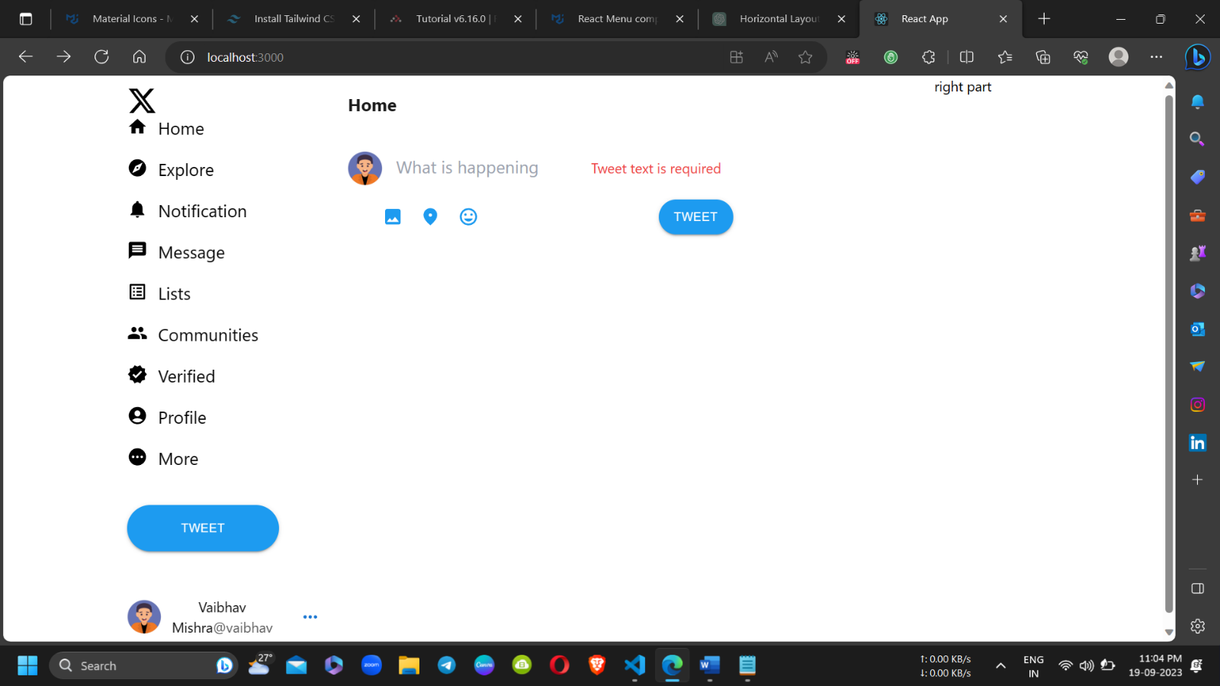

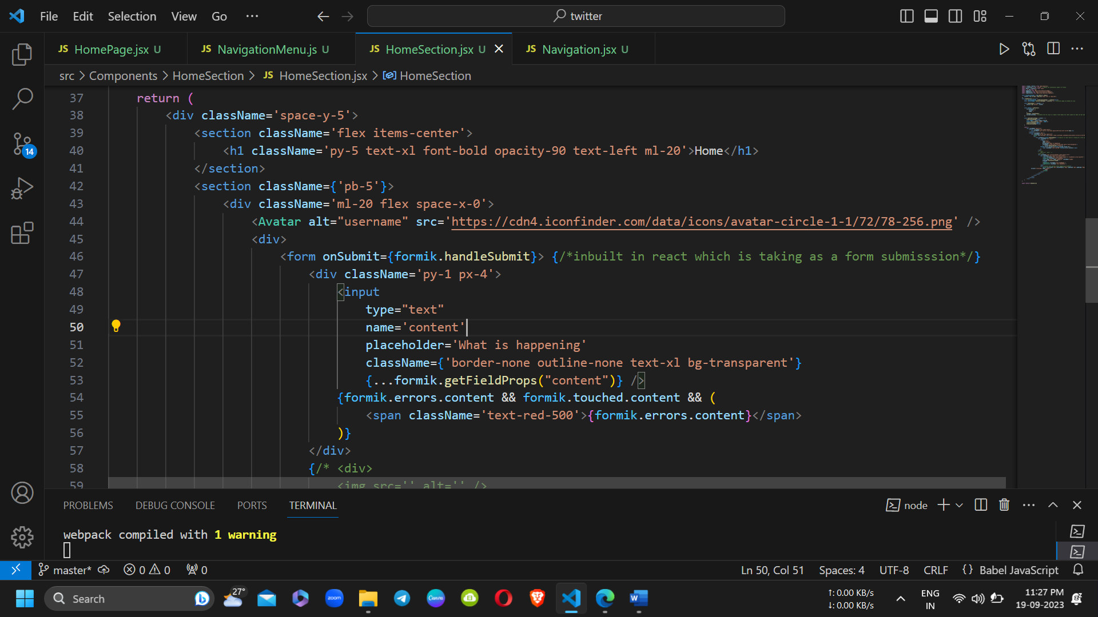

DAY 4: 22/09/23

1. Started building tweet card.
2. Used same avatar and created name , id name , and inserted blue tick image.
3. Same button code to delete and edit code
4. Event handler is console only.
5. Learned about function calling variables, quote(simple and backtick which is used in curly bracket).
6. Inserted post image created border for that
7. Now for the bottom part imported all 5 icons and defined there color , mouse pointer cursor and onclick action , color change.
8. Fixed and learned some alignment
9. <https://chat.openai.com/share/98b4b12b-4710-42ba-bae1-56c0ffaad258>

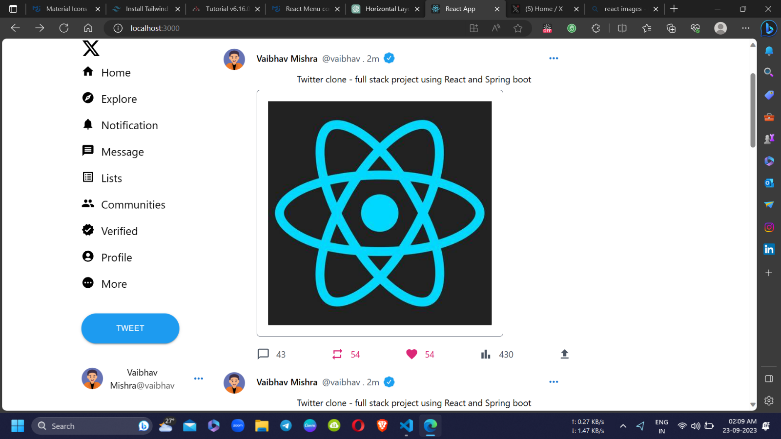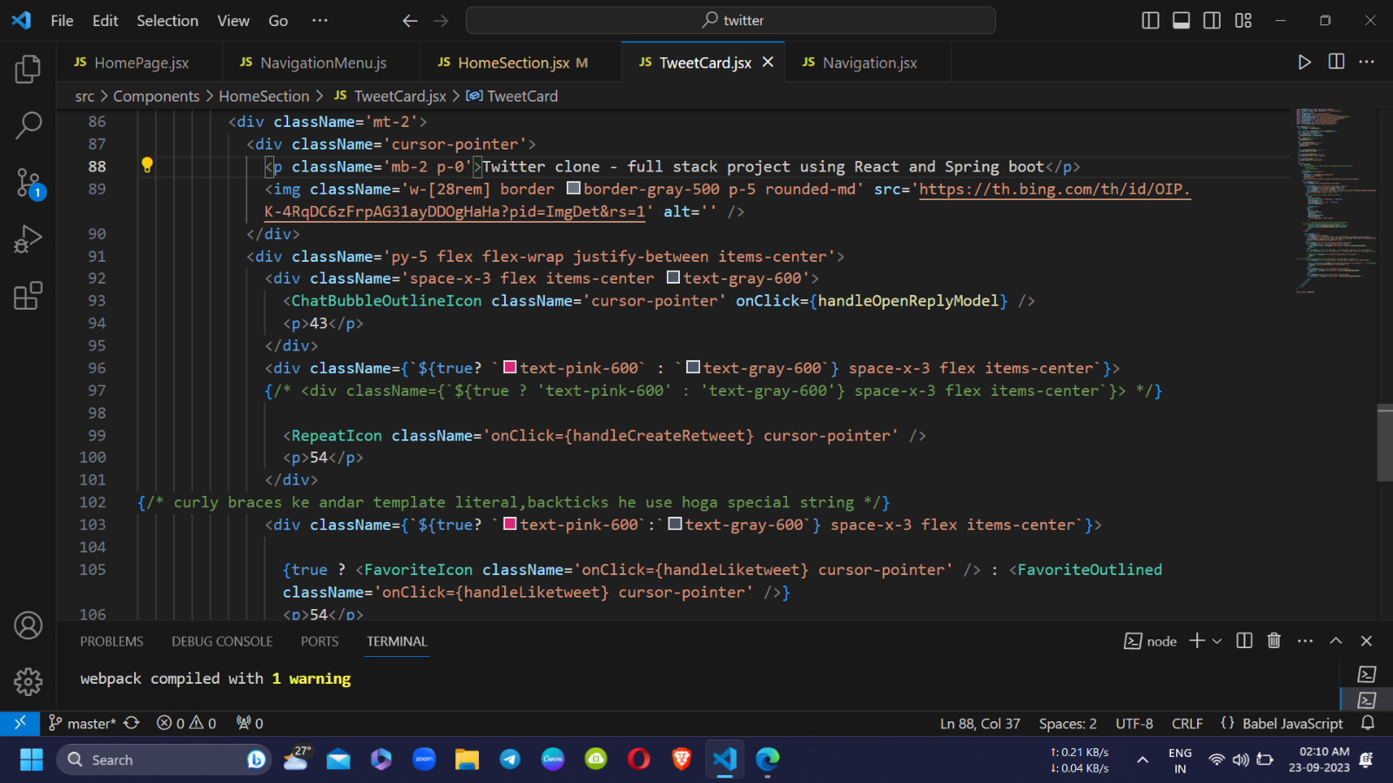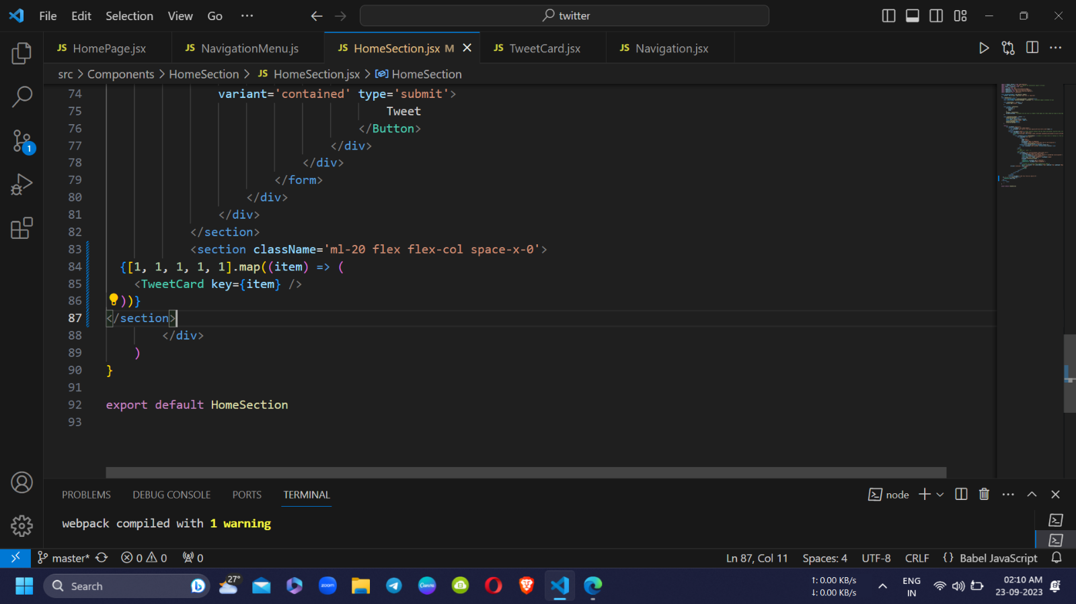

DAY 5: 27/09/23

1. Created right part of the page.
2. Learn about home page divided into 12 columns and how the page is set for multiple screens ms md lg.
3. Imported search icon and darkmode icon.
4. Get verified.
5. Fixed some alignment.

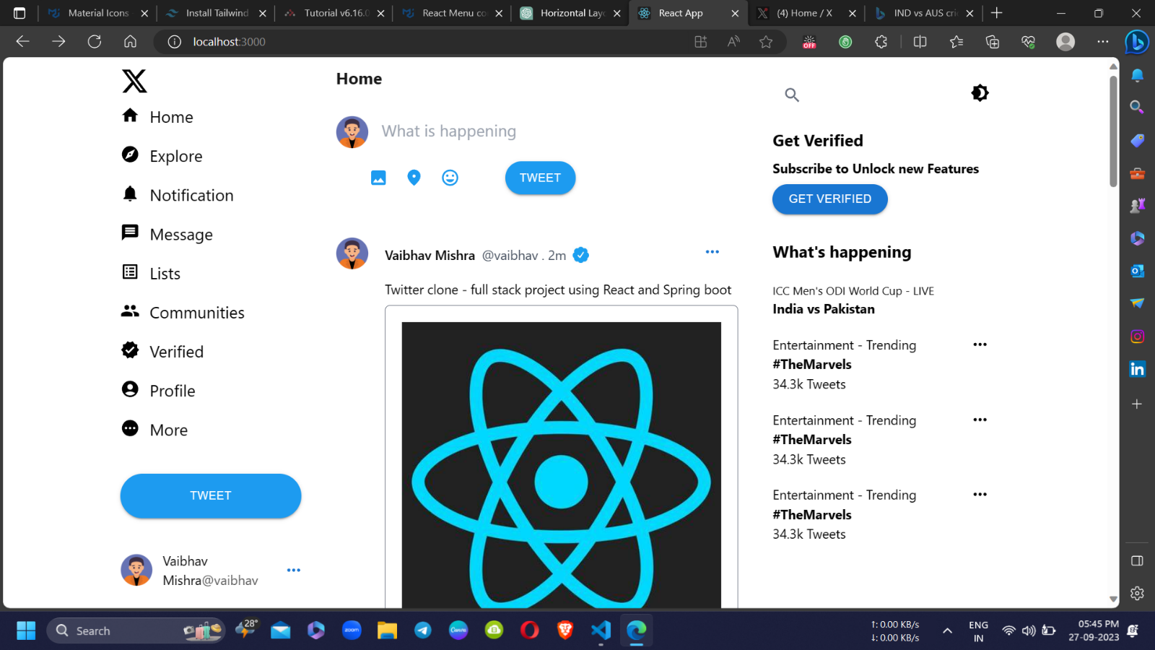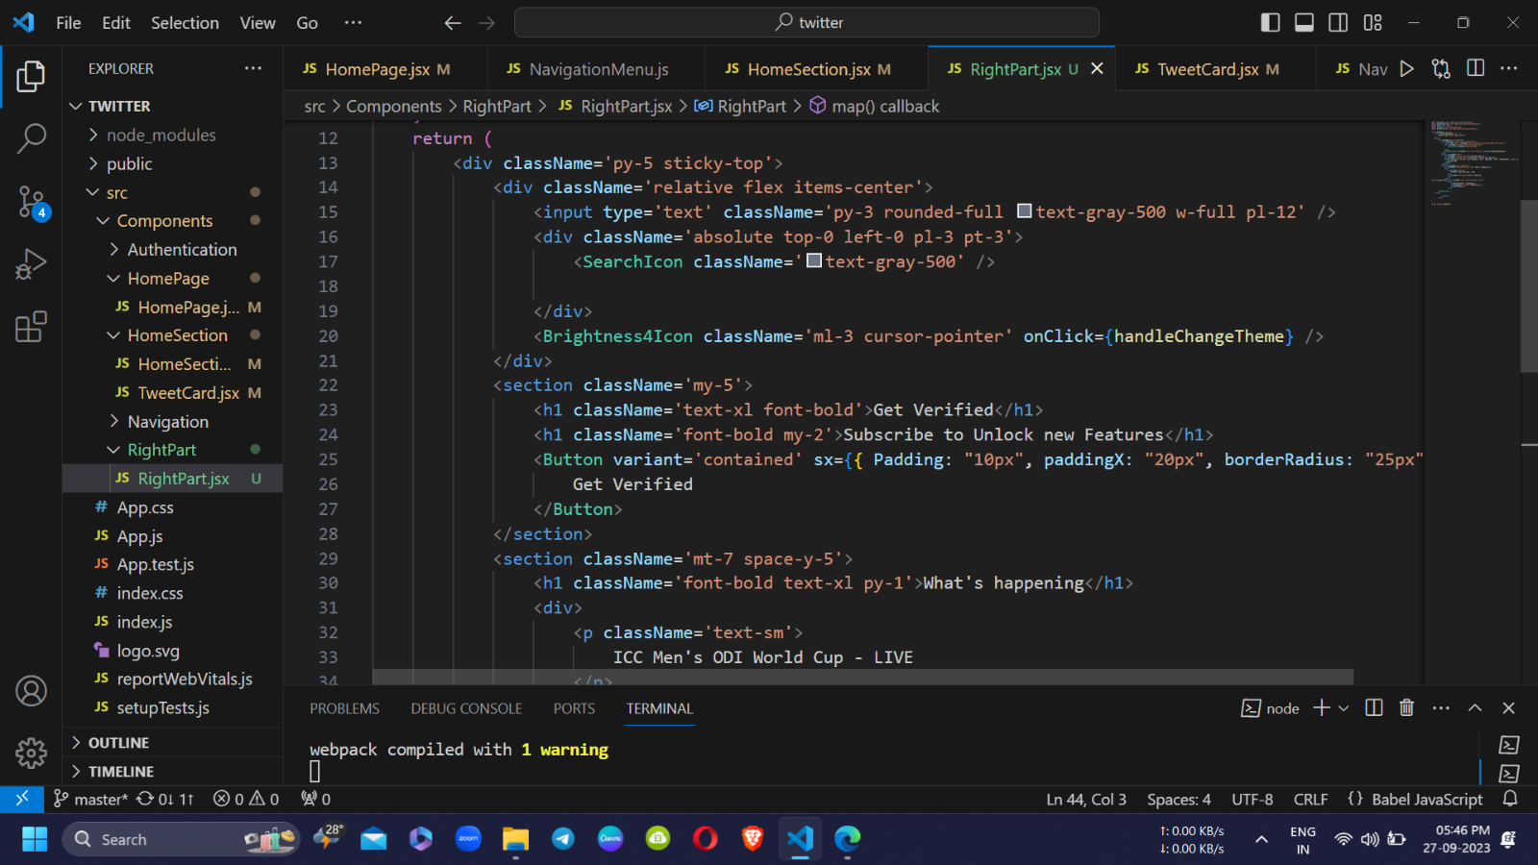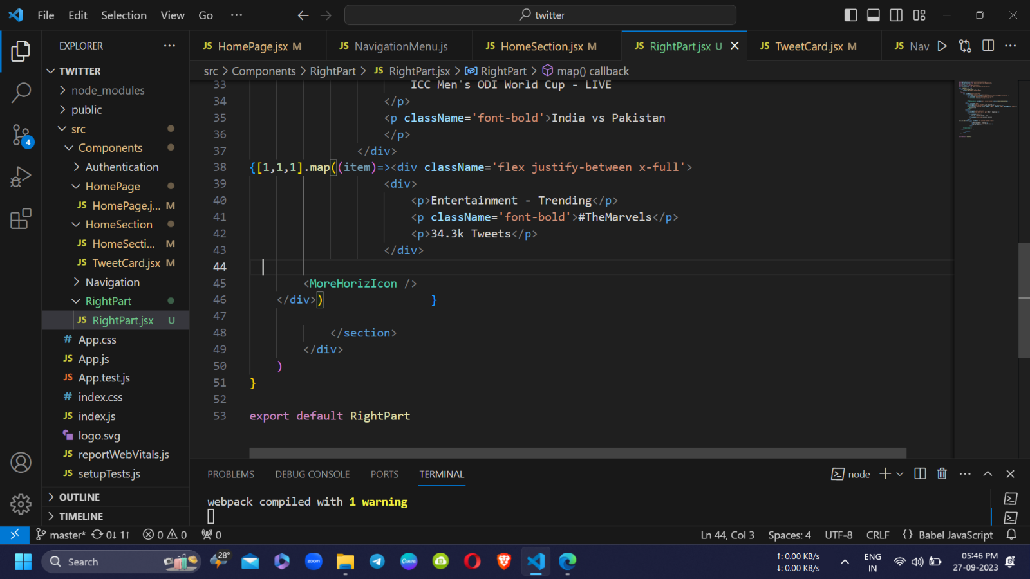

DAY 6: /09/23